
Application of Analytical Quality by Design concept for bilastine and its degradation impurities determination by hydrophilic interaction liquid chromatographic method

The objective of this research paper is to develop a hydrophilic interaction liquid chromatographic method for the analysis of bilastine and its degradation impurities following Analytical Quality by Design approach. Two Design of Experiments (DoE) methodologies are implemented for method optimization and robustness testing.
The DoE method applied for optimization is Box Behnken design. The factors (independent variables) examined in this stage are: X₁ = acetonitrile content in the mobile phase (%), X₂ = ammonium acetate concentration in the aqueous phase (mmol/L) and X₃ = pH of the aqueous phase. All the factors are continuous. The responses (dependent variables) examined are: k₃ = retention factor of Impurity 2 and a₂ = selectivity factor of critical peak pair.
The DoE method applied for robustness testing is fractional factorial design. The factors examined in this stage are: A = acetonitrile content in the mobile phase (%), B = buffer concentration in aqueous phase (mM), C = pH of the aqueous phase, D = mobile phase flow rate (mL/min) and E = column temperature (ºC). All the factors are continuous and the responses examined are the same as those of the first stage.
Isalos version used: 2.0.6
Scientific article: https://www.sciencedirect.com/science/article/abs/pii/S0731708516302084

Optimization stage

Step 1: Box Behnken Design
In the first tab named “Action” define the factors in the column headers and fill each column with the low and high levels of the corresponding factors. This tab can be renamed “Box Behnken”. Afterwards, apply the Box Behnken method: DOE $→$ Response Surface $→$ Box Behnken

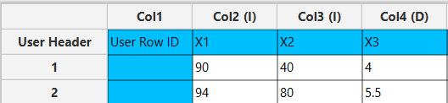

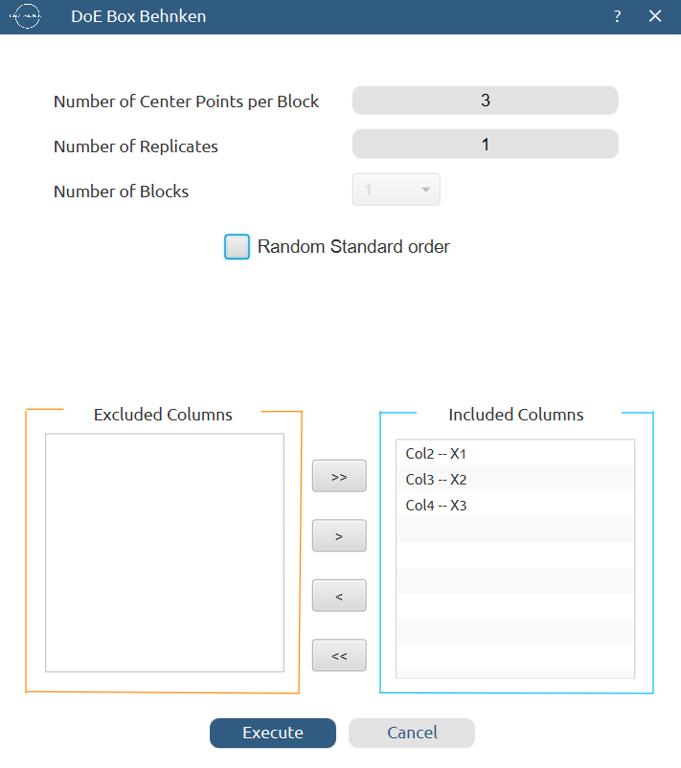

Results (right spreadsheet):
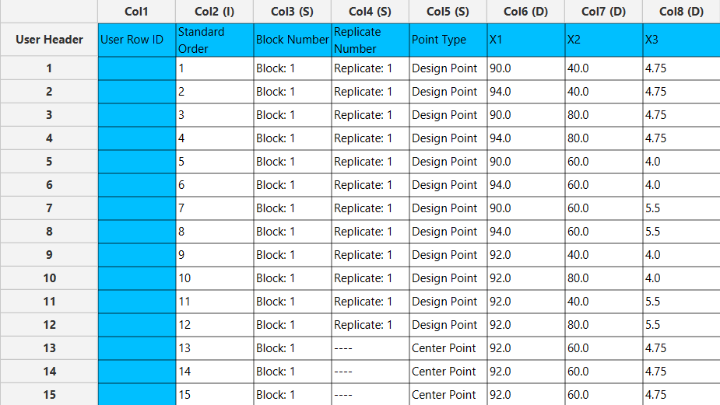

Step 2: Definition of response variables
Create a new tab named “Responses - BBD” and define the responses in the column headers. Fill each column with the values of the corresponding responses that were observed and make sure the values follow the order of the experiments as given by the Box Behnken method. Then, select all columns to be transferred to the right spreadsheet: Data Transformation $→$ Data Manipulation $→$ Select Column(s)
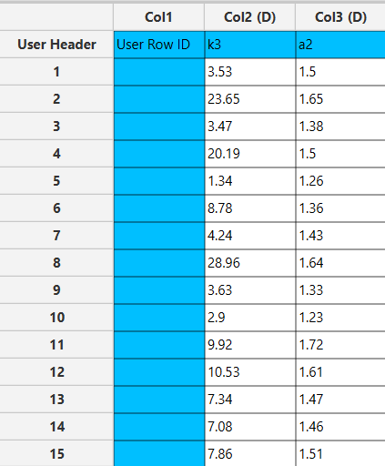
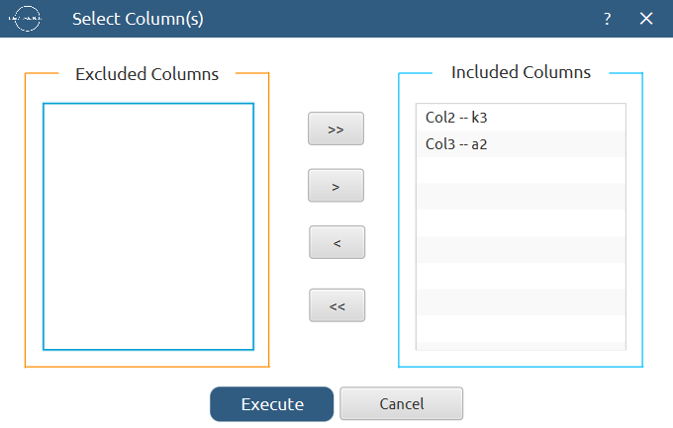

Step 3: Data isolation
Create a new tab named “Data - BBD” and import the results from the “Box Behnken” and “Responses - BBD” spreadsheets by right clicking on the left spreadsheet. Then, select only the factors and responses columns to be transferred to the right spreadsheet: Data Transformation $→$ Data Manipulation $→$ Select Column(s)

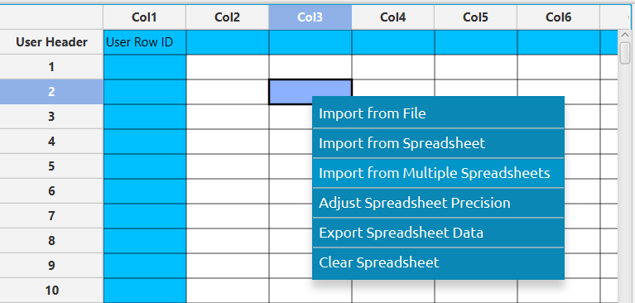

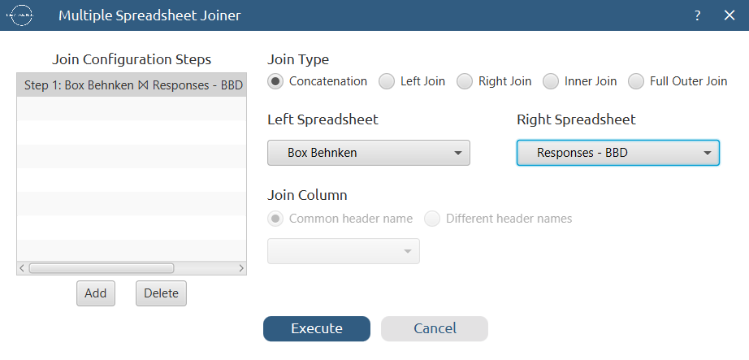
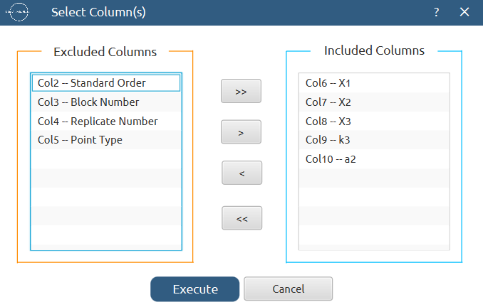

Results:
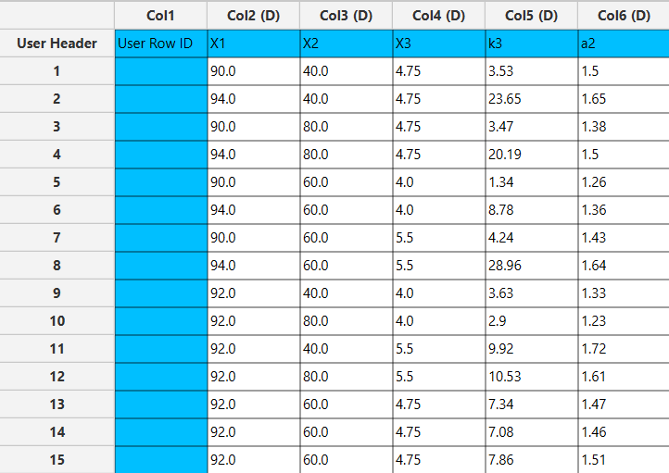

Step 4: Normalization
Create a new tab named “Normalized data - BBD” and import the results from the “Data - BBD” spreadsheet. Afterwards, normalize the factor columns to take values in the range [-1, 1]: Data Transformation $→$ Normalizers $→$ Min-Max



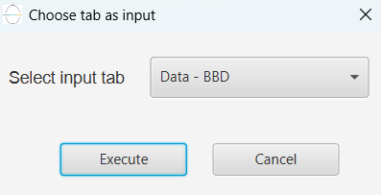

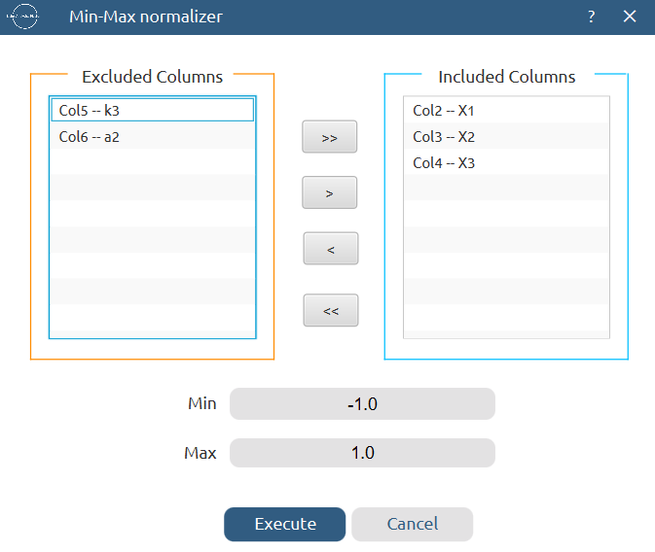
Results:
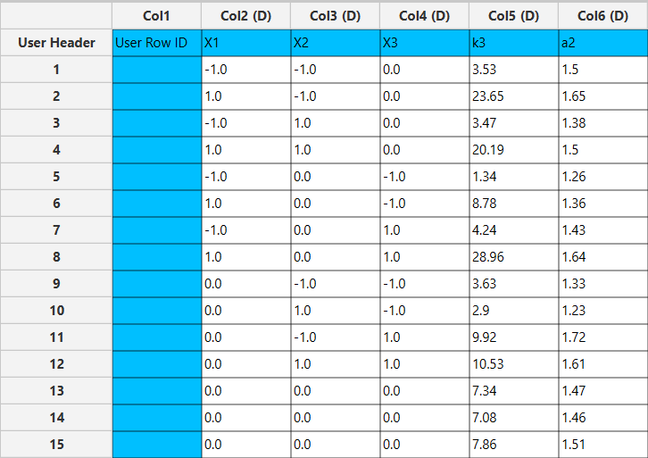

Step 5: Regression
The goal here is to produce a regression equation that includes main effects, two-factor interactions, and quadratic effects for k₃:
$$Y={b_{0}+b}_{1}X_{1}+b_{2}X_{2}+b_{3}X_{3}+b_{12}X_{1}X_{2}+b_{13}X_{1}X_{3}+b_{23}X_{2}X_{3}+b_{11}{X_{1}}^{2}+b_{22}{X_{2}}^{2}+b_{33}{X_{3}}^{2}$$
Create a new tab named “Regression – k₃ - BBD” and import the results from the spreadsheet “Normalized data - BBD”. Afterwards, fit a generalized linear model to the data: Analytics $→$ Regression $→$ Statistical fitting $→$ Generalized Linear Models
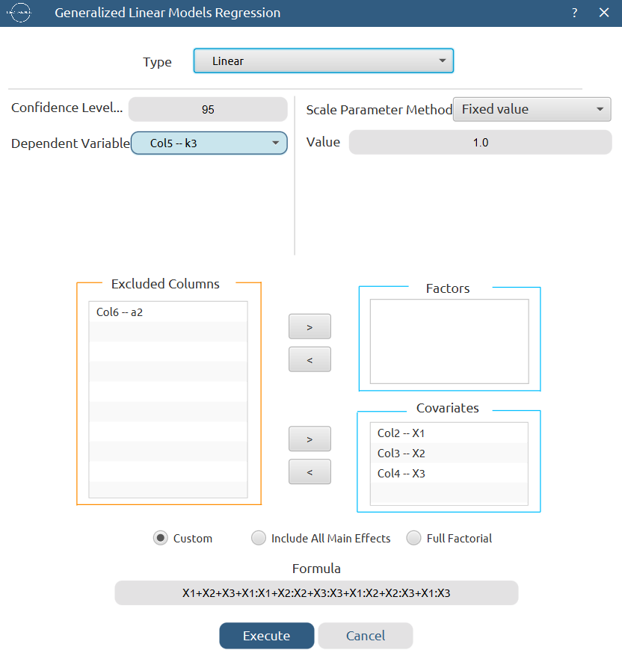

Results:

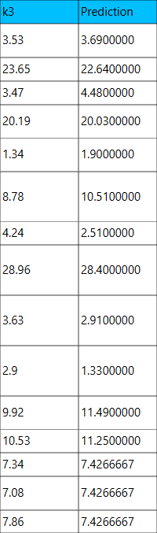
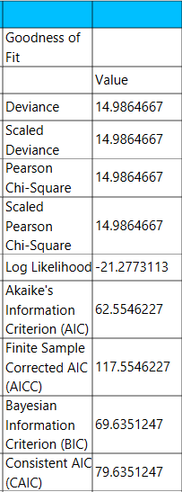

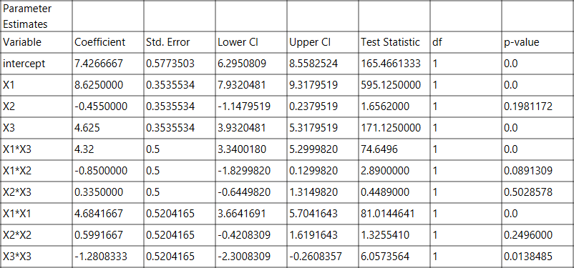

Repeat this step for the second response variable. Results, a₂:

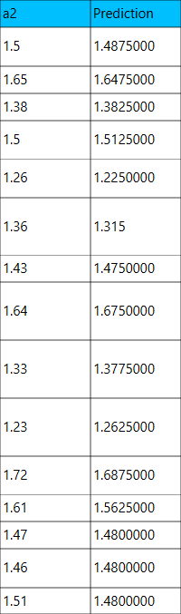
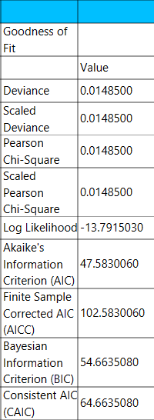

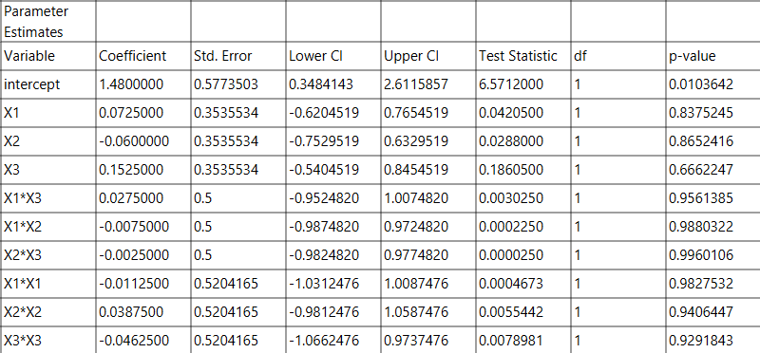

Step 6: Regression Metrics

Create a tab named “Metrics – k₃ - BBD” and import the results from the spreadsheet “Regression – k₃ - BBD”. Then, produce the regression metrics for the k₃ regression equation: Statistics $→$ Model Metrics $→$ Regression Metrics

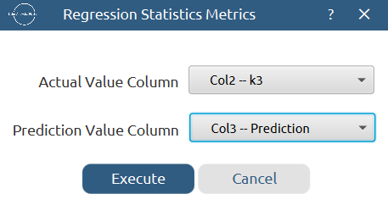

Results:
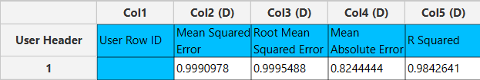

Repeat this step for the second response variable. Results, a₂:
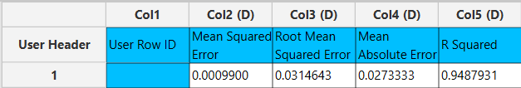

Step 7: Analysis of Covariance
Create a new tab named “ANCOVA – k3 - BBD” and import the results from the spreadsheet “Normalized data - BBD”. Afterwards perform analysis of covariance for k₃: Statistics $→$ Analysis of (Co)Variance $→$ ANCOVA

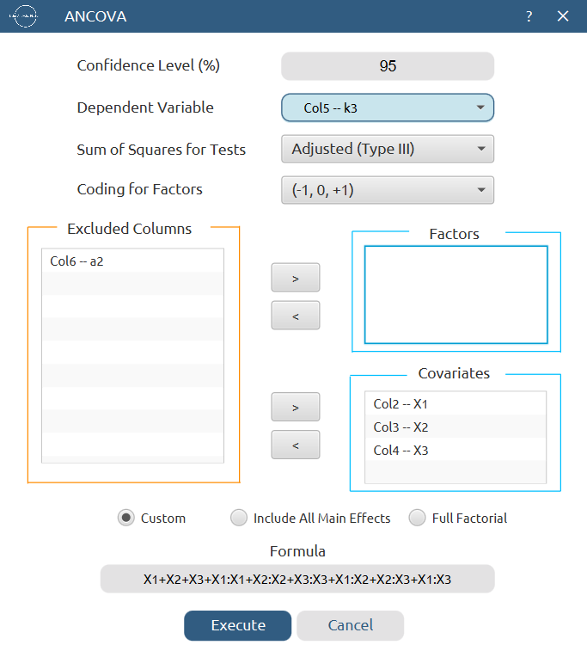

Results:
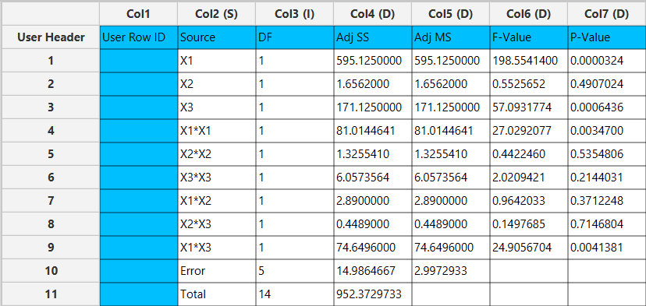

Repeat this step for the second response variable. Results, a₂:
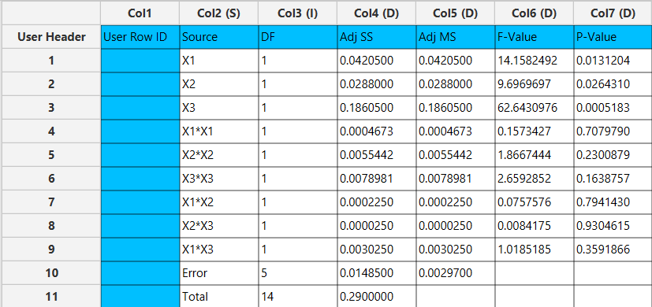

Robustness testing stage

Step 8: Fractional Factorial Design
Create a new tab named “Fractional Factorial” and define the factors of this stage in the column headers. Afterwards, fill each column with the low and high levels of the corresponding factors and apply the fractional factorial method: DOE $→$ Screening $→$ Fractional Factorial

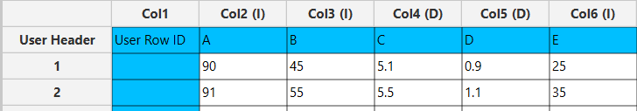

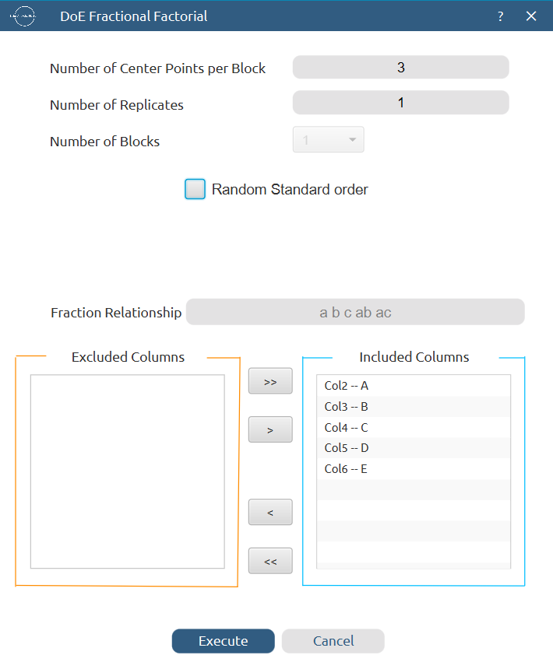

Results:
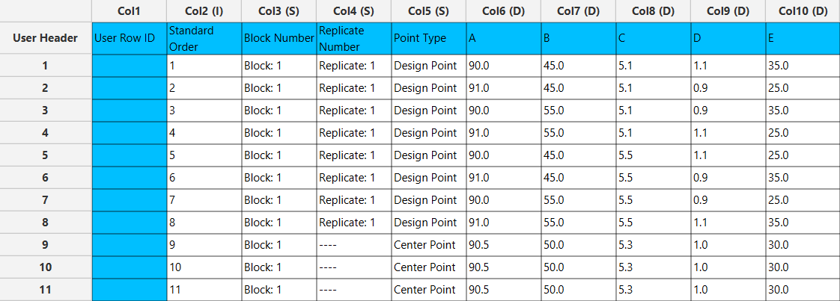

Step 9: Definition of response variables
Create a new tab named “Responses - FF” and define the responses in the column headers. Fill each column with the values of the corresponding responses that were observed and make sure the values follow the order of the experiments as given by the fractional factorial method. Then, select all columns to be transferred to the right spreadsheet: Data Transformation $→$ Data Manipulation $→$ Select Column(s)

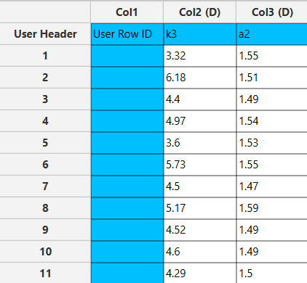

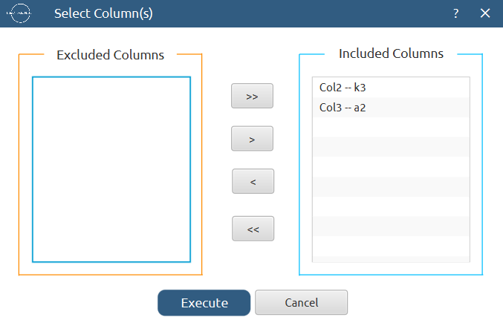

Step 10: Data isolation
Create a new tab named “Data - FF” and import the results from the “Fractional Factorial” and “Responses - FF” spreadsheets by right clicking on the left spreadsheet. Then, select only the factors and responses columns to be transferred to the right spreadsheet: Data Transformation $→$ Data Manipulation $→$ Select Column(s)

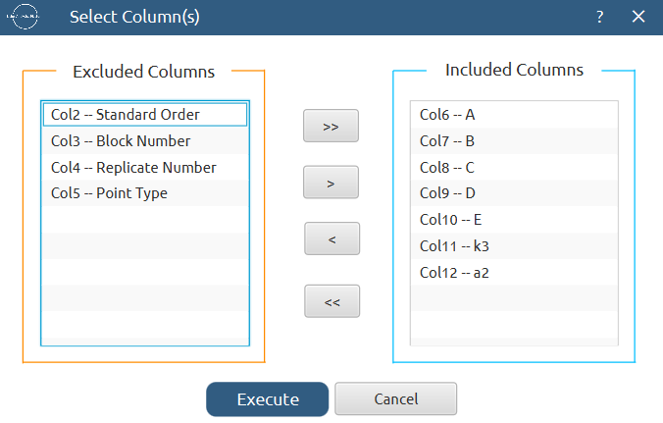

Results:
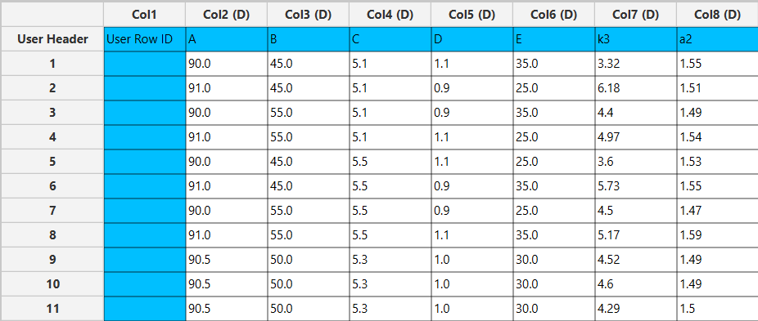

Step 11: Normalization
Create a new tab named “Normalized data - FF” and import the results from the “Data - FF” spreadsheet. Afterwards, normalize the factor columns to take values in the range [-1, 1]: Data Transformation $→$ Normalizers $→$ Min-Max

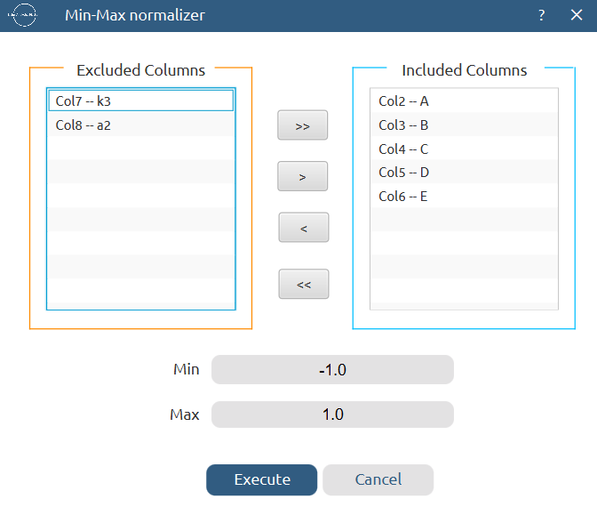

Results:
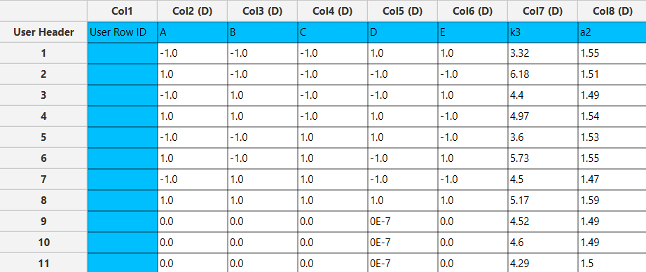

Step 12: Regression
The goal here is to produce a regression equation that includes main effects for k₃:
$$Y={b_{0}+b}_{1}A+b_{2}B+b_{3}C+b_{4}D+b_{5}E$$
Create a new tab named “Regression – k₃ - FF” and import the results from the spreadsheet “Normalized data - FF”. Afterwards, fit a generalized linear model to the data: Analytics $→$ Regression $→$ Statistical fitting $→$ Generalized Linear Models

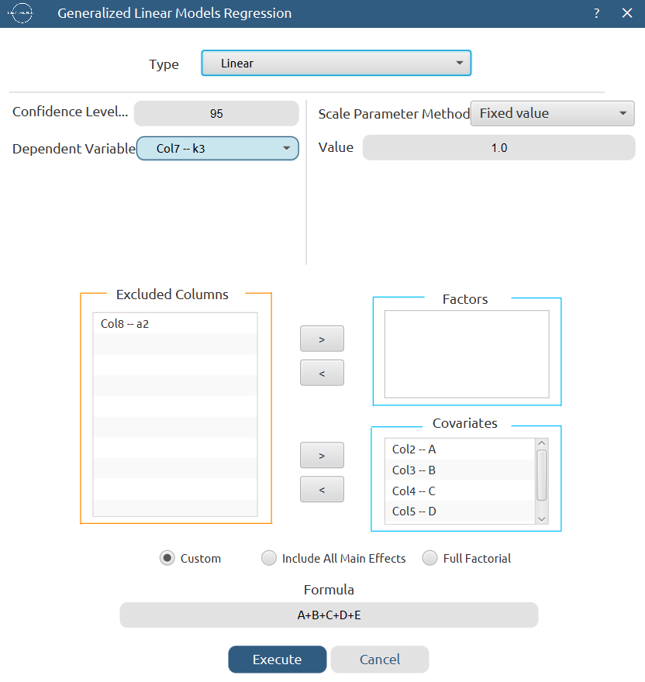

Results:

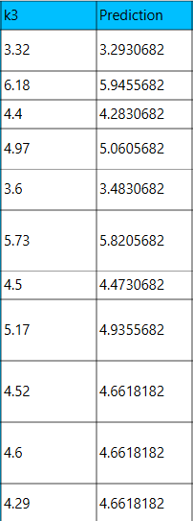

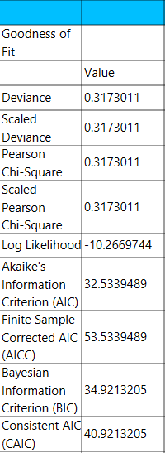

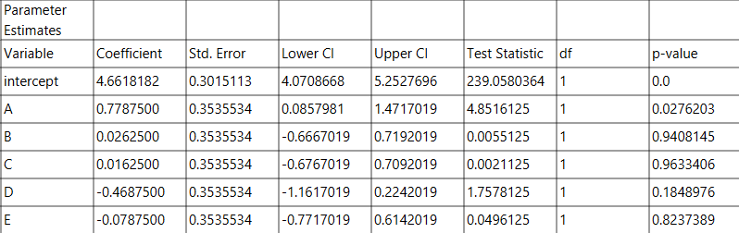

Repeat this step for the second response variable. Results, a₂:

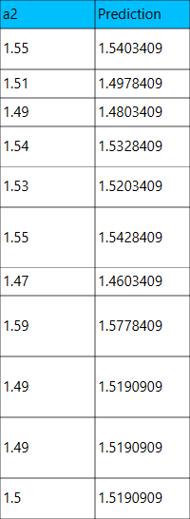
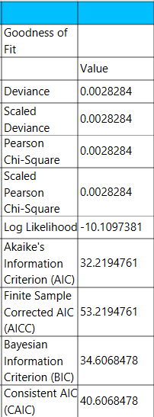

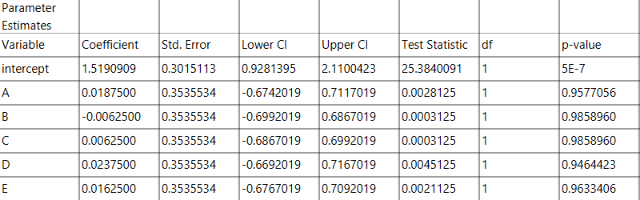

Step 13: Regression Metrics

Create a tab named “Metrics – k₃ - FF” and import the results from the spreadsheet “Regression – k₃ - FF”. Then, produce the regression metrics for the k₃ regression equation: Statistics $→$ Model Metrics $→$ Regression Metrics

Results:
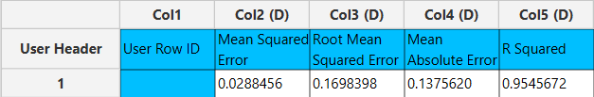

Repeat this step for the second response variable. Results, a₂:
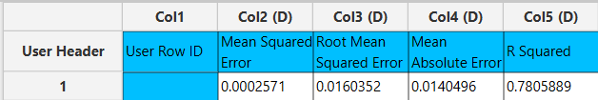

Step 14: Analysis of Covariance
Create a new tab named “ANCOVA – k3 - FF” and import the results from the spreadsheet “Normalized data - FF”. Afterwards perform analysis of covariance for k₃: Statistics $→$ Analysis of (Co)Variance $→$ ANCOVA

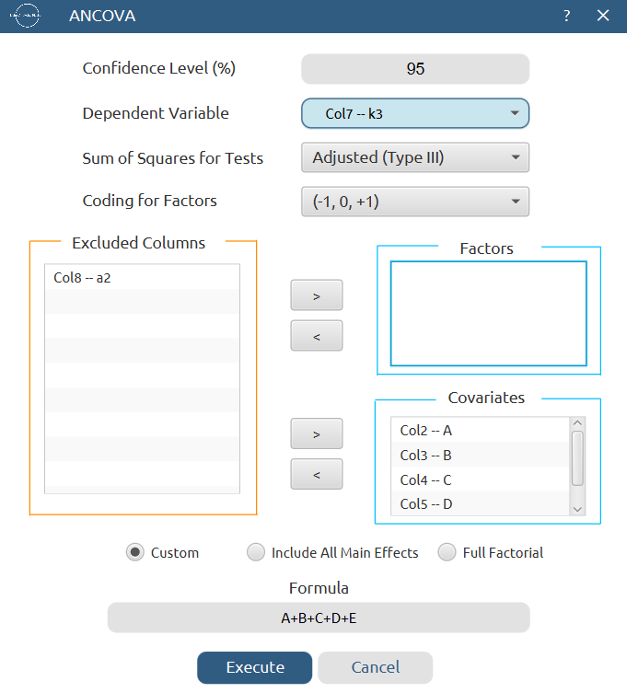

Results:
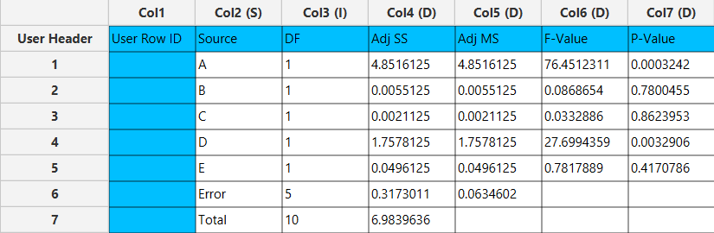

Repeat this step for the second response variable. Results, a₂:
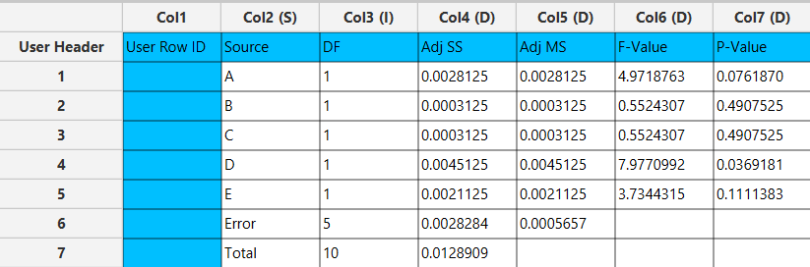

Final Isalos Workflow
The final workflow is presented below (doesn’t fully fit):
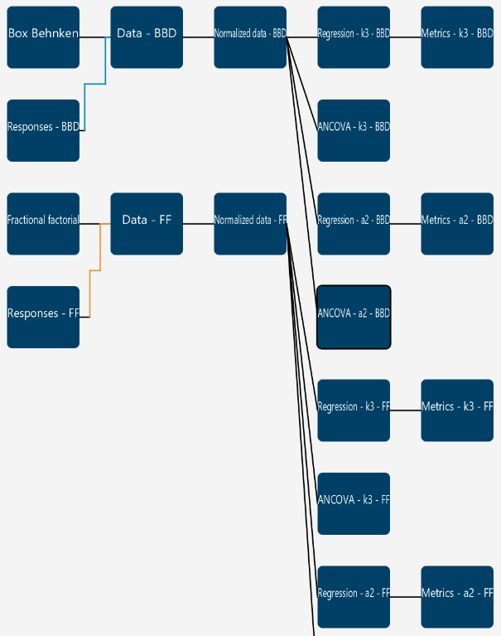

References
(1) Terzić, J.; Popović, I.; Stajić, A.; Tumpa, A.; Jančić-Stojanović, B. Application of Analytical Quality by Design Concept for Bilastine and Its Degradation Impurities Determination by Hydrophilic Interaction Liquid Chromatographic Method. Journal of Pharmaceutical and Biomedical Analysis 2016, 125, 385–393. https://doi.org/10.1016/j.jpba.2016.04.022.

